MEHRAN UNIVERSITY

OF ENGINEERING & TECHNOLOGY

JAMSHORO, PAKISTAN

Design the network and apply the knowledge of routing protocol to configure the RIP protocol in network on three routers.

Subject: COMPUTER NETWORKS (PR)

(Lab 10 - Tasks Solution)

|  |  |
| --- | --- |
| **Roll No:** | **22SW028** |
| **Section:** | **I** |

**LAB TASKS:**

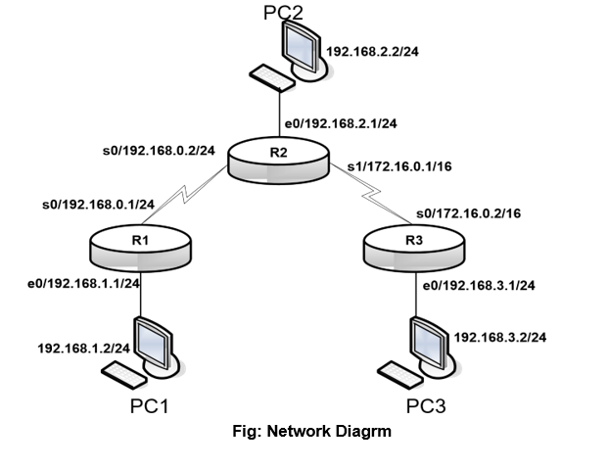

Looking at the above figure and by following the lab manual instructions, the network was built using 3 routers with rip protocol. The network screenshot is given below

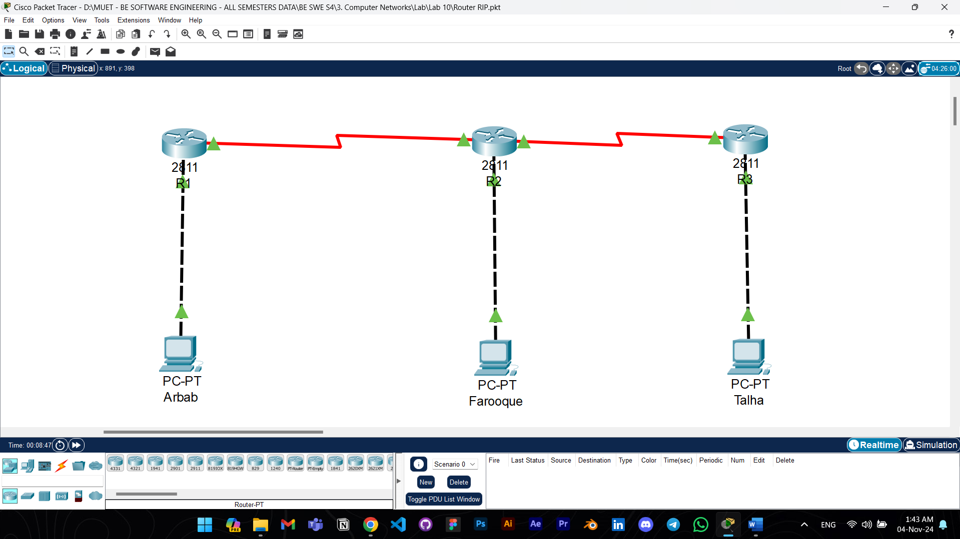

Answers to the questions given in Lab Manuals are below.

**Answers to Questions:**

**1. Why is the interface Serial0 changed state to down?**

Ans: The interface Serial0 changes to the "down" state typically because it lacks an active physical connection or has not yet detected a signal from the other end of the serial link. This could happen due to an unplugged or improperly connected cable, or if the other side of the connection has not been configured and brought up.

**2. Are all the necessary interfaces up?**

Ans: Yes, all necessary interfaces on both router 1 and 2 are up.

R1:

R2:

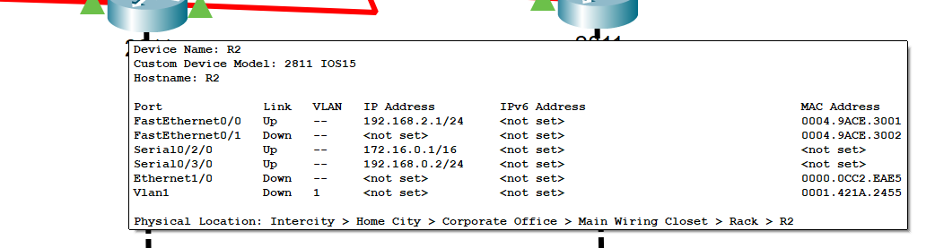

R3:

**3. What networks are displayed on Router3?**

Ans:

172.16.0.0 - Directly connected on Serial0.

192.168.3.0 - Directly connected on Ethernet0.

192.168.0.0, R 192.168.1.0, and R 192.168.2.0 - Learned via RIP from other routers

**4. Which network is directly connected to the Ethernet port on Router3?**

Ans: The network 192.168.3.0/24 is directly connected to the Ethernet0 port on Router3, as mentioned in the above answer.

**5. Why are there three network entries on Router2?**

Ans: Router2 has three network entries because it connects three distinct networks:

172.16.0.0 - Connected to Router3 through Serial1.

192.168.0.0 - Connected to Router1 through Serial0.

192.168.2.0 - Connected to its own Ethernet0 interface.

**6. List the shortest listed route in the routing table of R2.**

Ans:

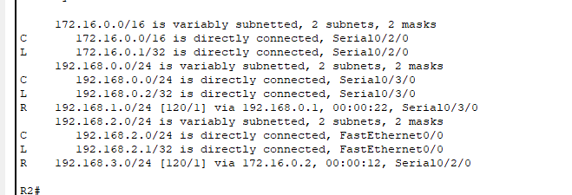

The shortest route are the ones directly connected.

C 192.168.2.0 (connected to Ethernet0)

C 192.168.0.0 (connected to Serial0)

C 172.16.0.0 (connected to Serial1

**7. What is the administrative distance?**

Ans: The administrative distance for RIP is 120.

Note: The configuration commands aren’t added in the tasks as they are already present in the manual. The packet tracer file of the following task is also attached with the assignment.